We can set service bus performance trigger for this requirement which will be based on number of messages.

For this requirement min SKU for the service bus S1 so that we will be able to configure auto scaling condition.

Steps:

1. configure autoscaling rules on webapp:
2. Now, let’s configure autoscaling for the consumer web app based on the number of messages in the queue.
3. In the “Scale-out (App Service plan)” feature under “Settings”, we select “Custom autoscale”, we provide a name for the setting, and we choose “Scale based on a metric” as the scale model. To balance performance and cost, we can also specify instance limits:

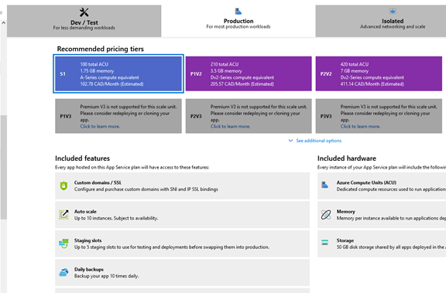

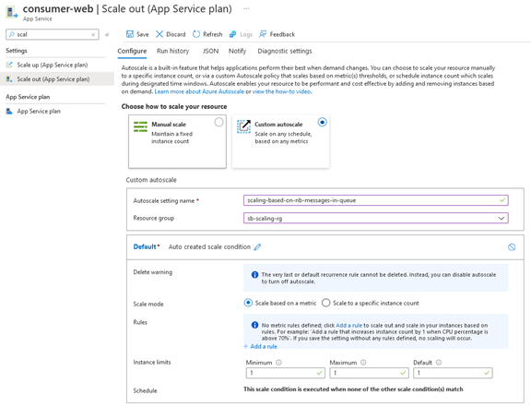

1. We then click on “+ Add a rule” and we configure the parameters as highlighted in the figure below:



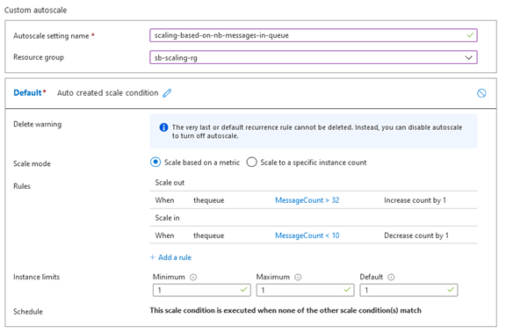

Based on the messages it will scale automatically.